Experiment- 01

Objective: To study and perform basic network diagnostic and configuration commands.
Commands:
- ipconfig
It displays the IP configuration of the computer including IP address, subnet mask and default getaway.
Syntax: ipconfig
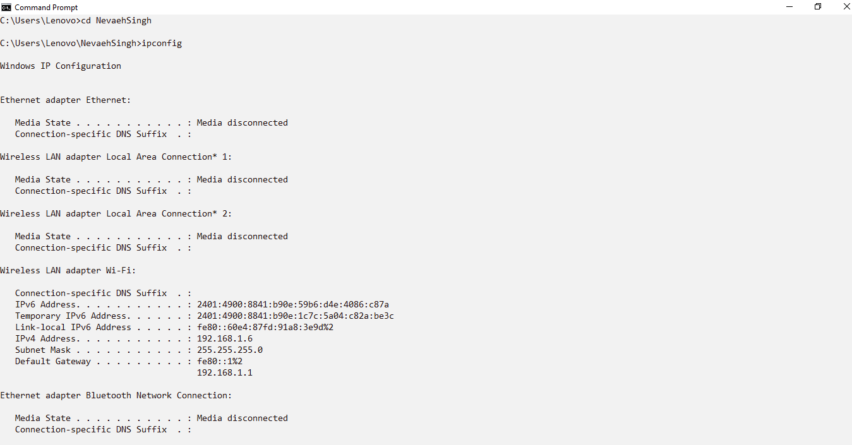
- hostname
It displays the name of the local computer.
Syntax: hostname
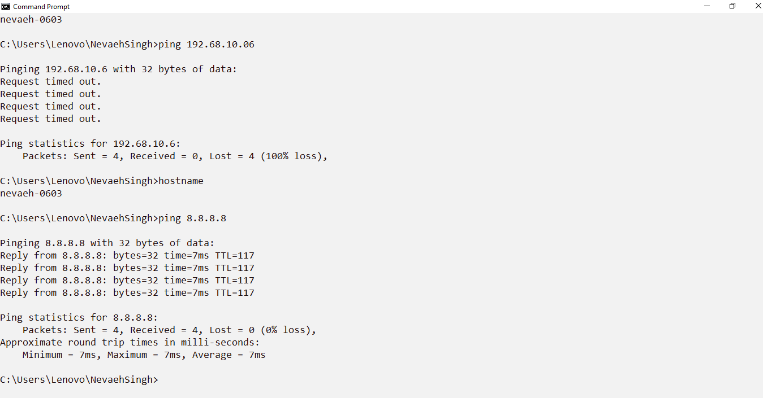
- ping
It tests connectivity between the local computer and a remote host by sending ICMP Echo Request packets.
Syntax: ping 8.8.8.8

- tracert
It traces the route taken by packets from the local computer to a destination host.
Syntax: tracert 8.8.8.8
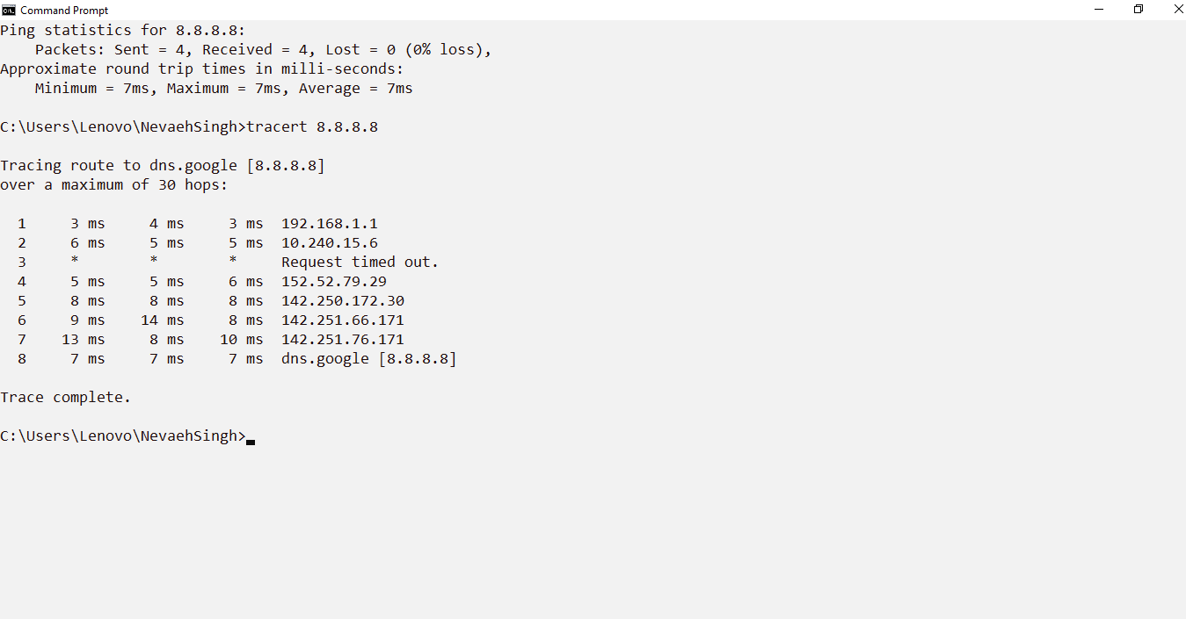
- pathping
It combines the functions of ping and tracert to identify network latency and packet loss at each hop.
Syntax: pathping 8.8.8.8
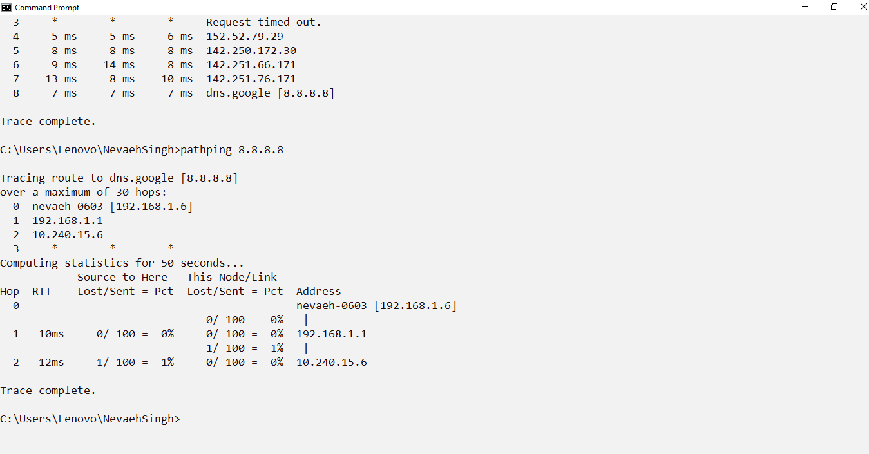
- arp
It displays and modifies the Address Resolution Protocol (ARP) cache which maps IP addresses to MAC addresses.
Syntax: arp -a
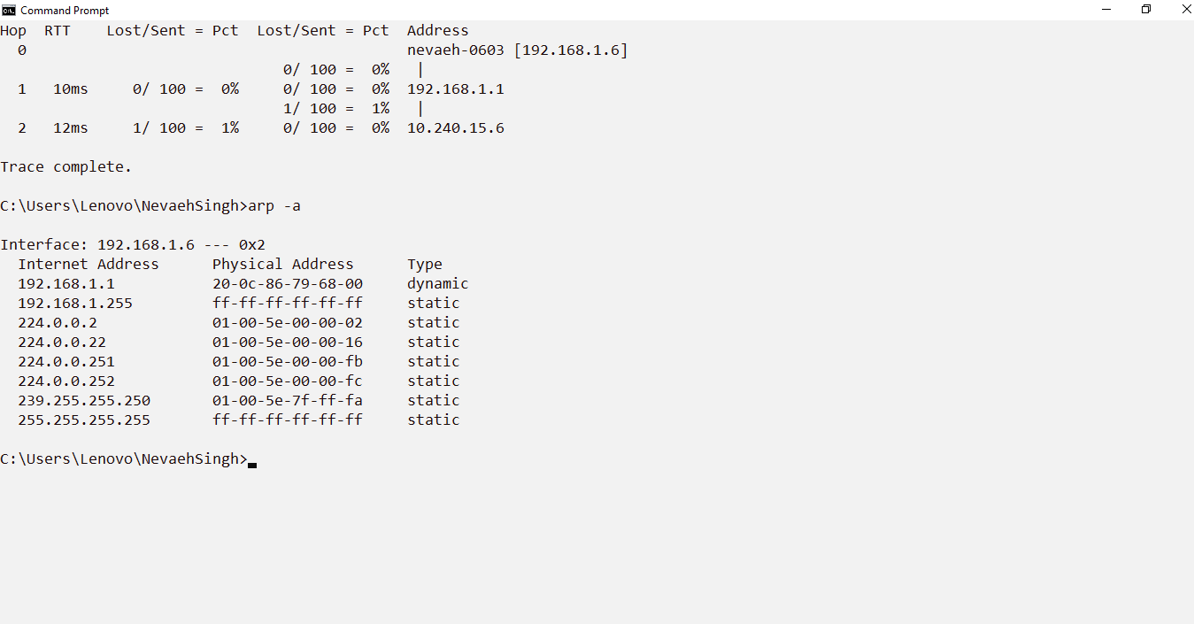
- netstat
It displays active network connections, listening ports, routing tables and network statistics.
Syntax: netstat -a
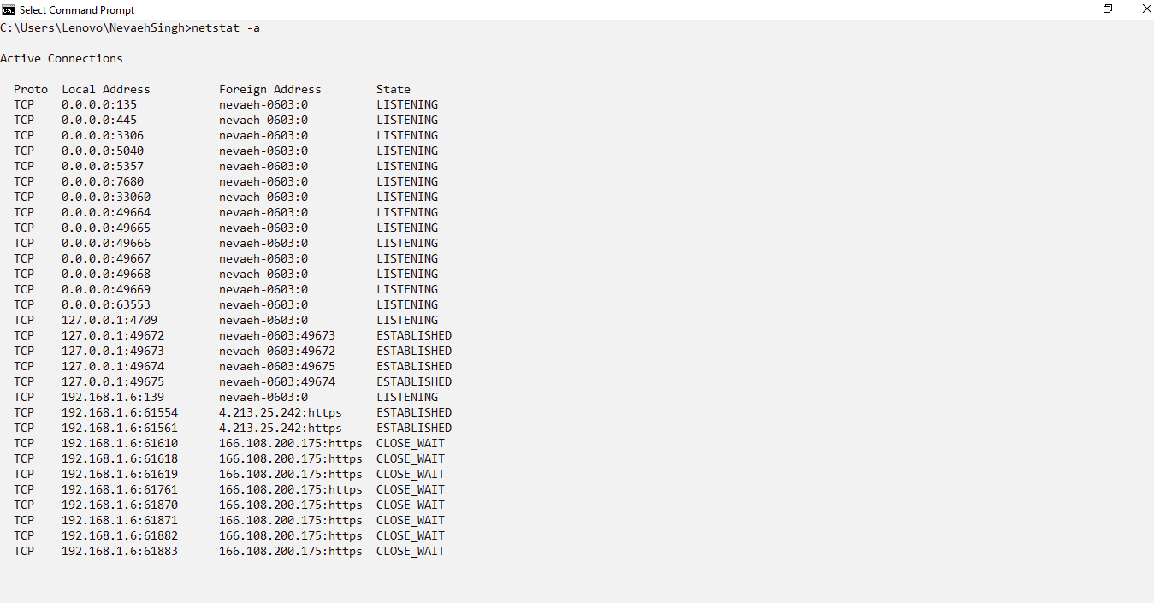
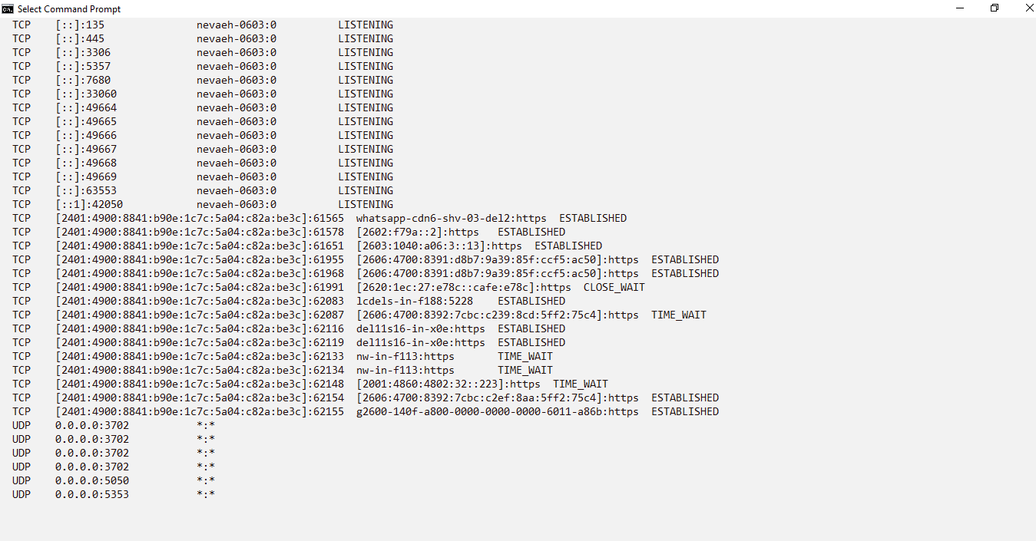

- nslookup
It queries the Domain Name System (DNS) to obtain the IP address associated with a domain name.
Syntax: nslookup google.com
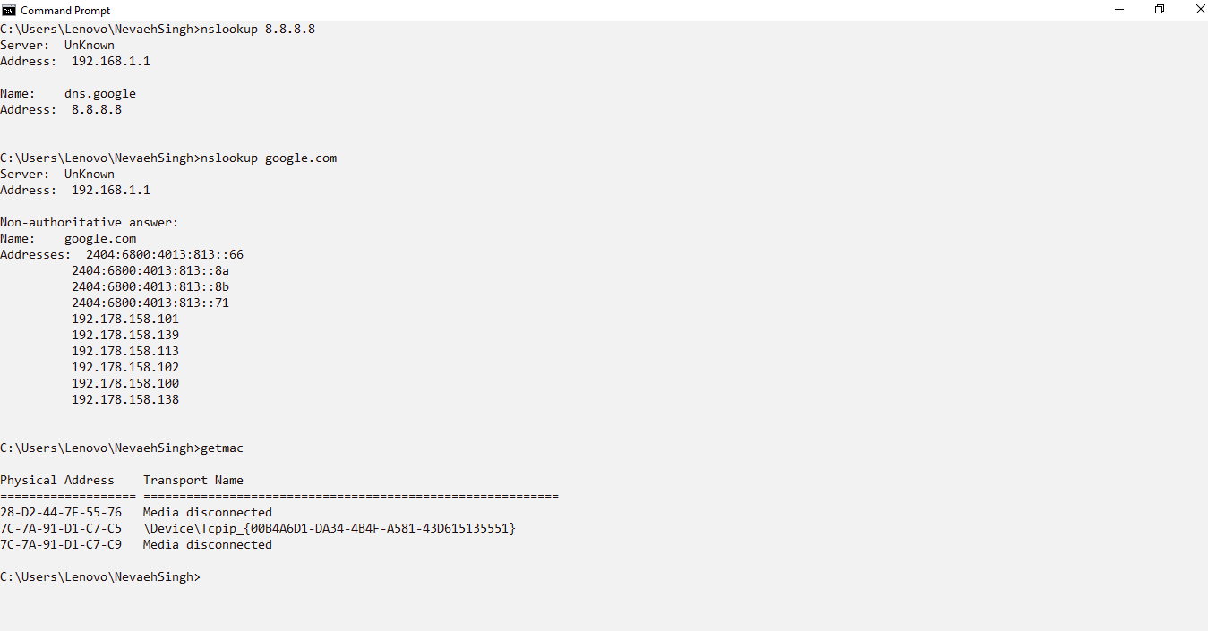
- getmac
It displays the Media Access Control (MAC) addresses of the network adapters installed on the computer.
Syntax: getmac

- netsh
A command line utility used to configure and manage various network settings.
Syntax: netsh wlan show profiles
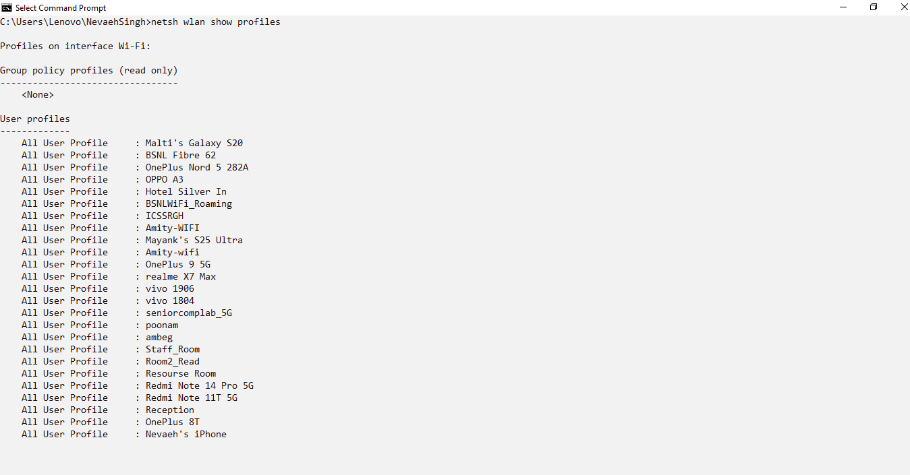
Experiment- 02
Objective: Introduction and Exploring Cisco Packet Tracer.
Theory: Cisco Packet Tracer is a network simulation software developed by Cisco Systems. It is used to design, configure and simulate computer networks in a virtual environment. The software provides various networking devices such as routers, switches, hubs and end devices for creating different network topologies.
It helps students understand networking concepts, practice configurations and troubleshoot network-related problems without requiring physical hardware.
Installation of Cisco Packet Tracer:
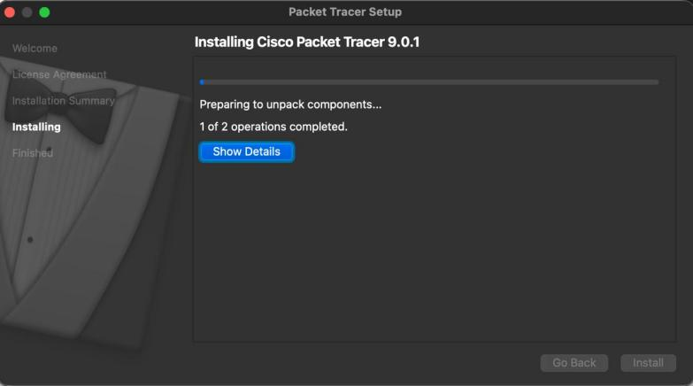
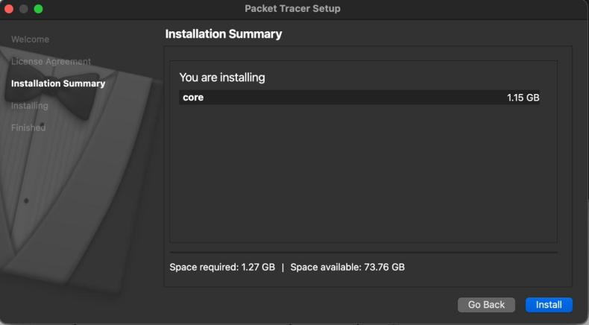
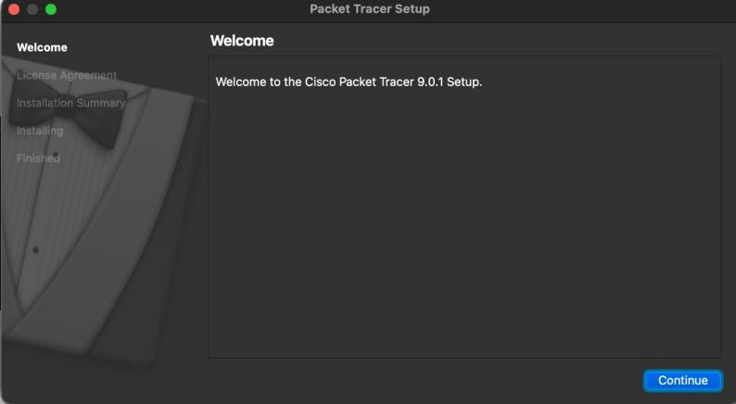
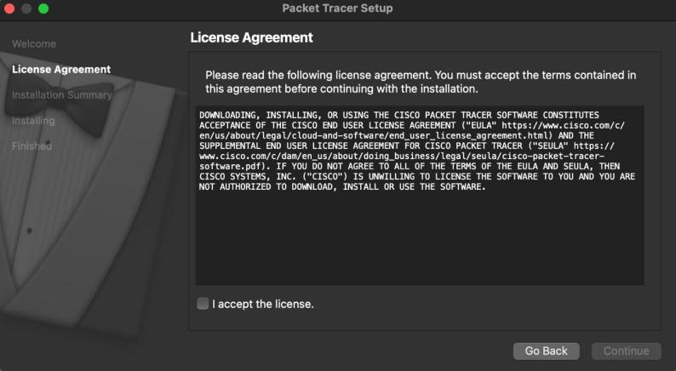
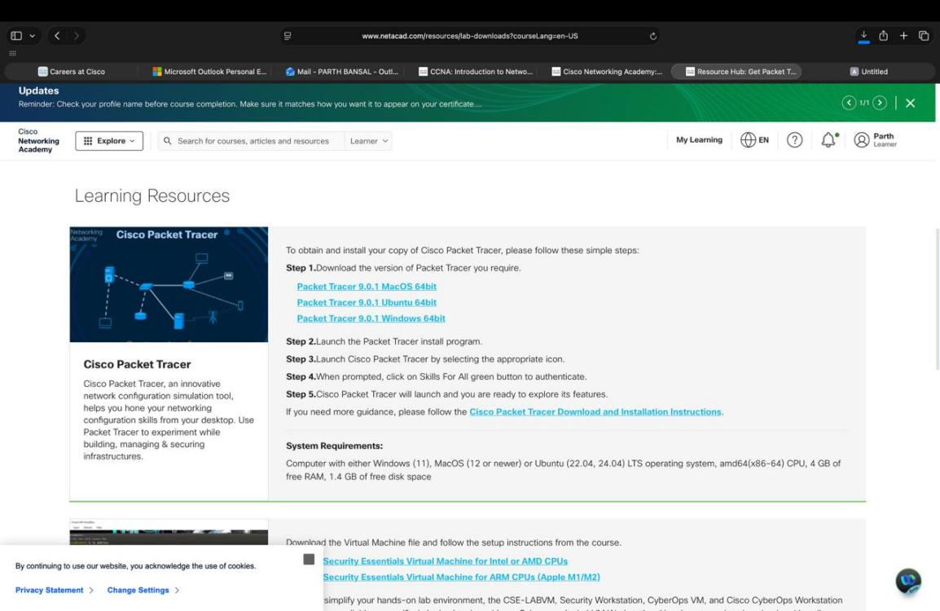
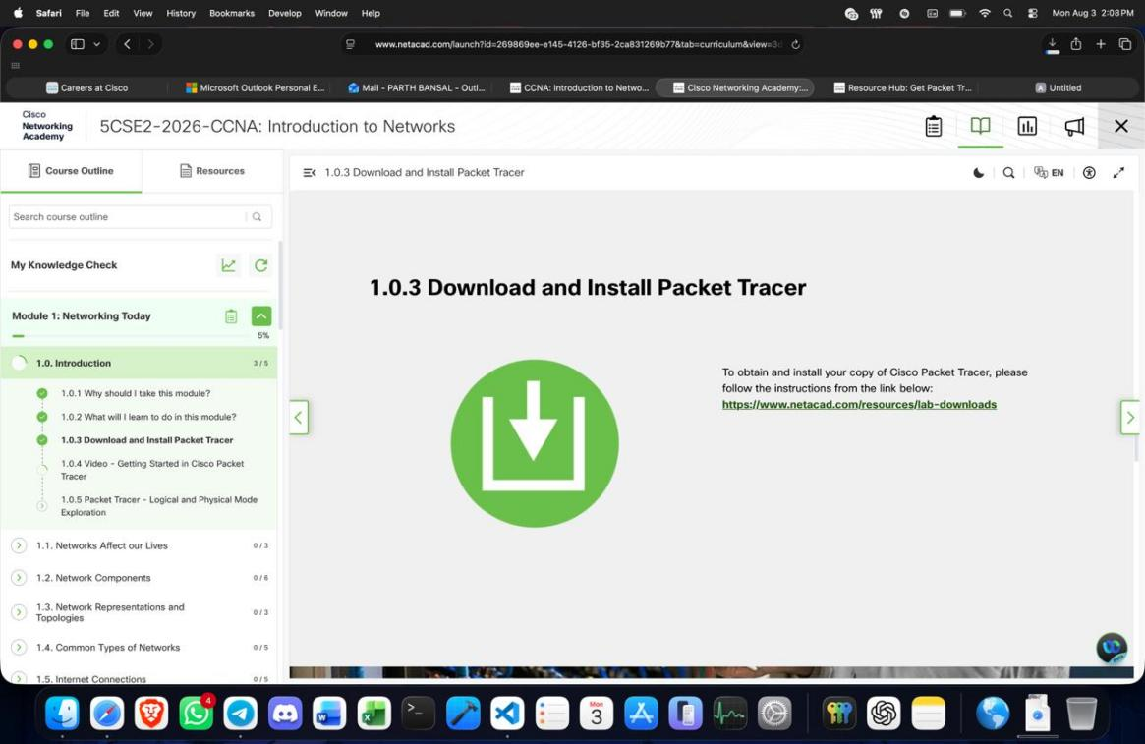
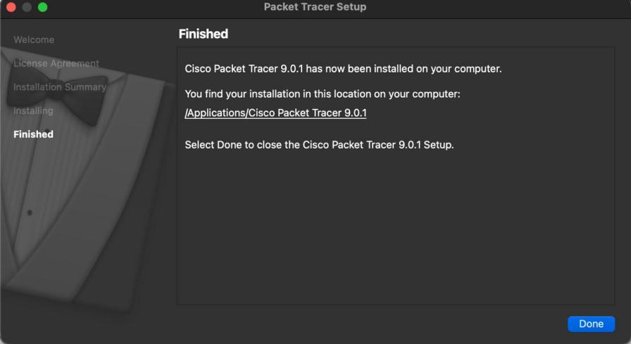
Cisco Packet Tracer was downloaded from the official Cisco Networking Academy website. After launching the setup, the Welcome screen appeared followed by the License Agreement which was accepted to continue. The Installation Summary displayed the installation details after which the software was installed successfully. Finally, the Finished screen confirmed the successful installation and the setup was completed by clicking Done.
Cisco Packet Tracer Interface
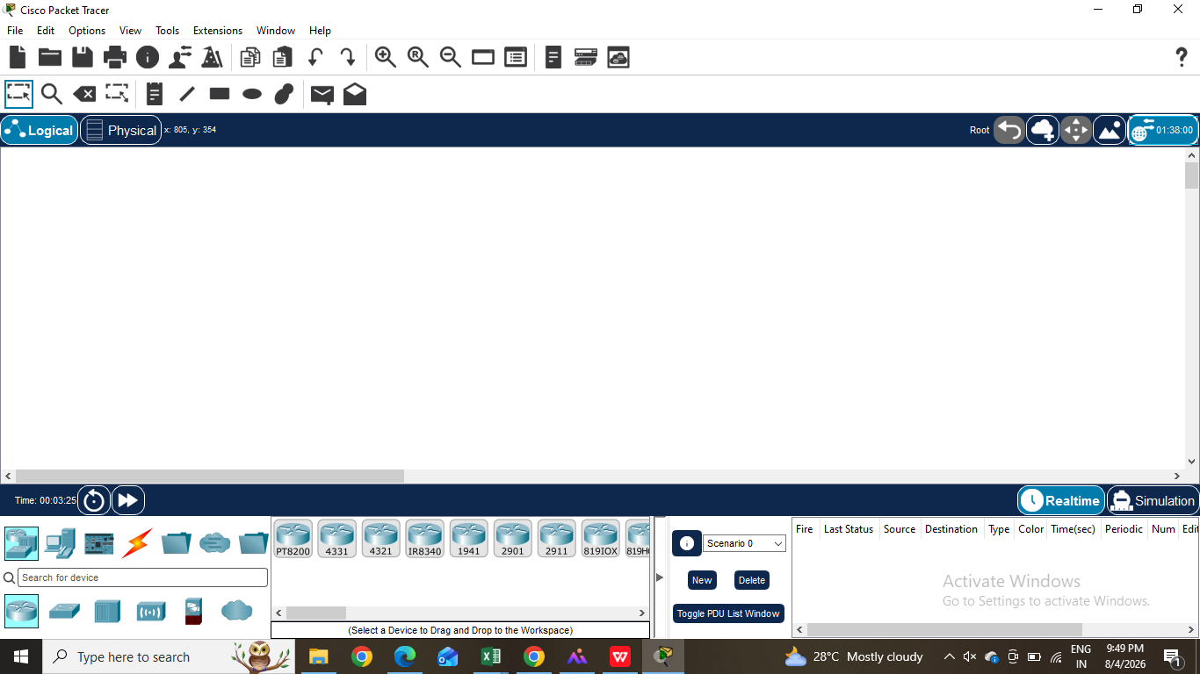
The Title Bar is located at the top of the window and displays the name of the application along with the current project. Below it is the Menu Bar which contains menus such as File, Edit, Options, View, Tools, Extensions, Window and Help. These menus provide options for creating, opening, saving, printing and managing projects as well as accessing various tools and settings.
Two Operating Modes- Cisco Packet Tracer provides two operating modes: Realtime and Simulation. Realtime Mode allows the network to function normally where devices communicate instantly and configurations can be tested in real time. Simulation Mode displays the movement of packets step by step, allowing users to observe how data travels through the network and making it easier to understand protocols and troubleshoot networking issues.

Device Selection Panel- The Device Selection Panel is located at the bottom-left corner of the Cisco Packet Tracer interface and is used to choose networking devices for creating a network topology. It contains different categories such as Network Devices, End Devices, Components, Connections, Wireless Devices, Security Devices and WAN Emulation.
Network Devices - It contains devices used to build and manage a computer network, such as routers and switches.
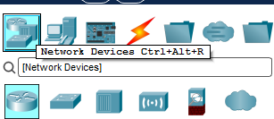
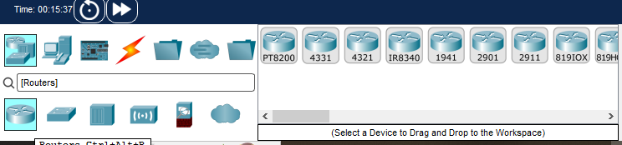
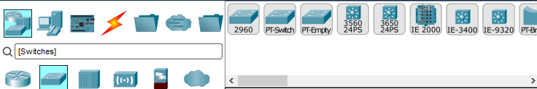
Inside Network Devices category, we have following data type available:
- Routers – Connect different networks and route data packets between them.
- Switches – Connect devices within the same local area network (LAN) and forward data efficiently.
- Hubs – Connect multiple devices and broadcast incoming data to all connected ports.
- Wireless Devices – Provide wireless connectivity for devices using Wi-Fi technology.
- Security Devices – Protect the network from unauthorized access using features such as firewalls.
- WAN Emulation – Simulates wide area network (WAN) connections to test communication over long distances.
End Devices -It includes devices used by users to access the network such as PCs, laptops and servers.
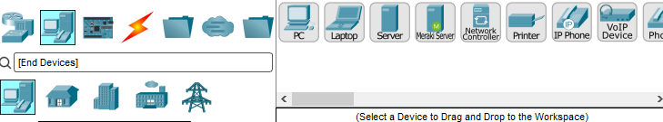
Components – It contains hardware modules and accessories used to expand or customize network devices.
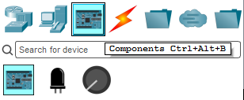
Connections – It provides different types of cables and links used to connect networking devices.
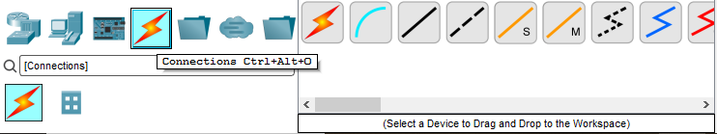

Result: The Cisco Packet Tracer interface was successfully explored and its basic components including the Device Selection Panel, Realtime Mode and Simulation Mode were identified and understood.

Experiment- 03

Objective: To establish Peer- To- Peer connection between two PCs.
Software used: Cisco Packet Tracer
Device Required: 2 PCs, 1Copper Cross-Over Cable
Theory: A peer-to-peer (P2P) network is a type of network in which two or more computers communicate directly with each other without the need for a dedicated server. Each computer acts as both a client and a server allowing it to share resources such as files, data and printers.
In Cisco Packet Tracer, a peer-to-peer connection between two PCs is created using a Copper Cross-Over cable. For communication to occur, both PCs must be assigned unique IP addresses that belong to the same network and have the same subnet mask. Once configured, connectivity can be verified using the ping command which checks whether data packets can be successfully transmitted and received between the two devices.
Peer-to-peer networks are simple, cost-effective and suitable for small networks where only a few devices need to communicate directly.
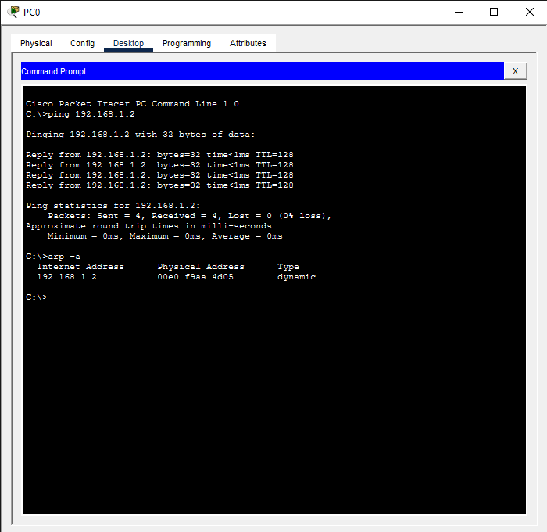
Output:

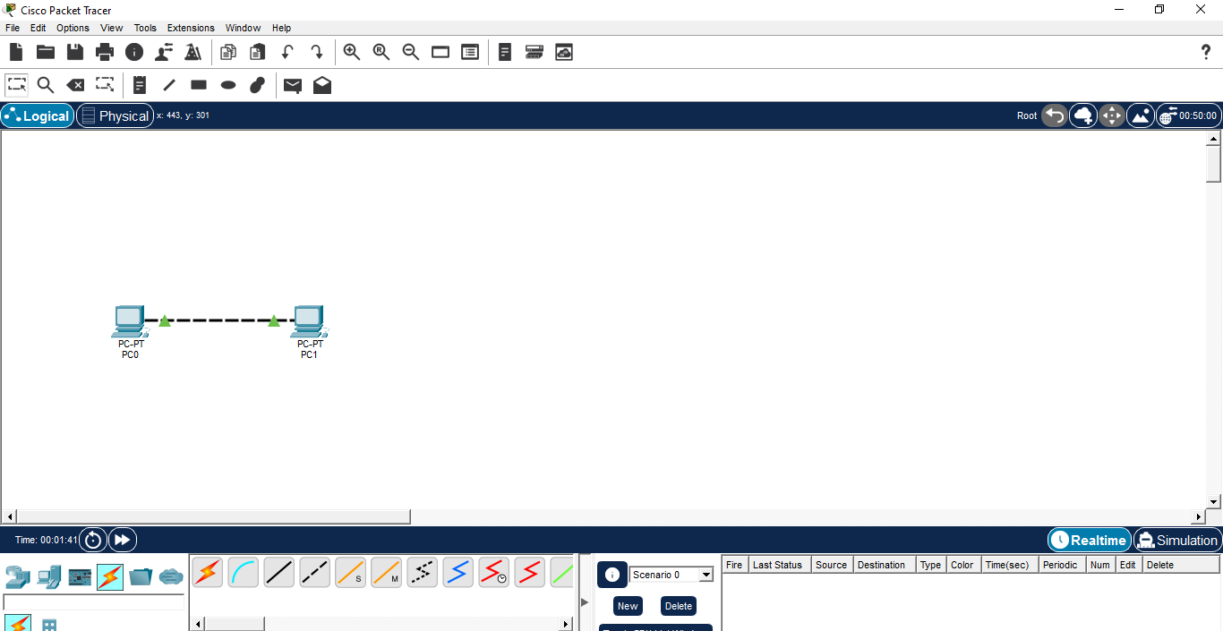

Result: A Peer- To- Peer connection was established between 2 PCs in Cisco Packet Tracer. Communication between the devices was verified using Ping command

